C++ Programming

PART – C

# 1 Using single inheritance, create a class ELECTRICITY that includes Tariff code, Zone, Meter number. Tariff code can be LT1, LT2 or LT3. Zone is either RURAL or URBAN.

# Create another class CUSTOMER that inherits ELECTICITY, and includes AccountID, CustName, Address, Previous reading and Present reading. Validate for Present reading >= Previous reading. A fixed amount of Rs. 200/- to be paid by all the customers. Prepare an electricity bill with all the details in a neat format using the following data:

|  |  |  |  |
| --- | --- | --- | --- |
| Tariff code | UNITS | RURAL | URBAN |
| LT1 | 0 to 40 | 6.80 | 6.80 |
| Above 40 | 7.00 | 7.00 |
| LT2 | 0 to 30 | 3.40 | 3.55 |
| 31 to 100 | 4.65 | 4.95 |
| Above 100 | 6.20 | 6.70 |
| LT3 | 0 to 50 | 7.25 | 7.75 |
| 51 & above | 8.55 | 8.95 |

#include<iostream.h>

#include<iomanip.h>

#include<string.h>

#include<conio.h>

#include<stdio.h>

int units,tarif;

float amount;

class electricity

{

protected:

char tarifcode[5];

char zone[5];

float mno;

};

class customer:public electricity

{

int accountid;

char custname[25];

char address[50];

int prev_read;

int cur_read;

public:

void getinput();

void calculatebill();

void display();

};

void customer::getinput()

{

cout<<"\n Enter account id:";

cin>>accountid;

cout<<"\n Enter meter no:";

cin>>mno;

cout<<"\n Enter customer name:";

gets(custname);

cout<<"\n Enter customer address:";

gets(address);

do

{

cout<<"\n Enter previous meter reading:";

cin>>prev_read;

cout<<"\n Enter current meter reading:";

cin>>cur_read;

if(cur_read<prev_read)

cout<<"\n Wrong input.....! Current reading should be greater then previous reading \n";

}while(cur_read<prev_read);

cout<<"\n Enter tarrif code(LT1/LT2/LT3)";

cin>>tarifcode;

cout<<"\n Enter zone(RURAL/URBAN)";

cin>>zone;

}

void customer::calculatebill()

{

units=cur_read-prev_read;

amount=200;

if((strcmpi(tarifcode,"LT1")==0)) tarif=0;

else if((strcmpi(tarifcode,"LT2")==0)) tarif=1;

else tarif=2;

switch(tarif)

{

case 0:

if(units<=40&&units>=0)

amount+=units*6.80;

else

amount+=40*6.80+(units-40)*7.0;

break;

case 1:

if(amount>=0&&units<=30)

{

if(!strcmpi(zone,"RURAL"))

amount+=units*3.4;

else

amount+=units*3.55;

}

else if(units>30&&units<=100)

{

if(!strcmpi(zone,"RURAL"))

amount+=30*3.4+(units-30)*4.65;

else

amount+=30*3.55+(units-30)*4.95;

}

else if(units>100)

{

if(!strcmpi(zone,"RURAL"))

amount+=30*3.4+70*4.65+(units-100)*6.2;

else

amount+=30*3.55+70*4.95+(units-100)*6.7;

}

break;

case 2:

if(amount>=0&&units<=50)

{

if(!strcmpi(zone,"RURAL"))

amount+=units*7.25;

else

amount+=units*7.75;

}

else if(units>50)

{

if(!strcmpi(zone,"RURAL"))

amount+=50*7.25+(units-50)*8.55;

else

amount+=50*7.75+(units-50)*8.95;

}

break;

}

}

void customer::display()

{

cout<<"\n Meter No :"<<mno;

cout<<"\n Customer Account Id :"<<accountid;

cout<<"\n Cusomer Name :"<<custname;

cout<<"\n Customer Address:"<<address;

cout<<"\n Tarif Code :"<<tarifcode;

cout<<"\n Zone :"<<zone;

cout<<"\n Previous Reading :"<<prev_read;

cout<<"\n Current Reading :"<<cur_read;

cout<<"\n No. of Units Consumed :"<<units;

cout<<"\n Total Amount to Pay(in rupees) :"<<setprecision(2)<<amount;

}

void main()

{

clrscr();

int wish=1;

customer c;

do

{

c.getinput();

c.calculatebill();

c.display();

cout<<"\n Do you wish to continue ? Enter 0 for No,1 for Yes : ";

cin>>wish;

}while(wish==1);

getch();

}

***Output:*** 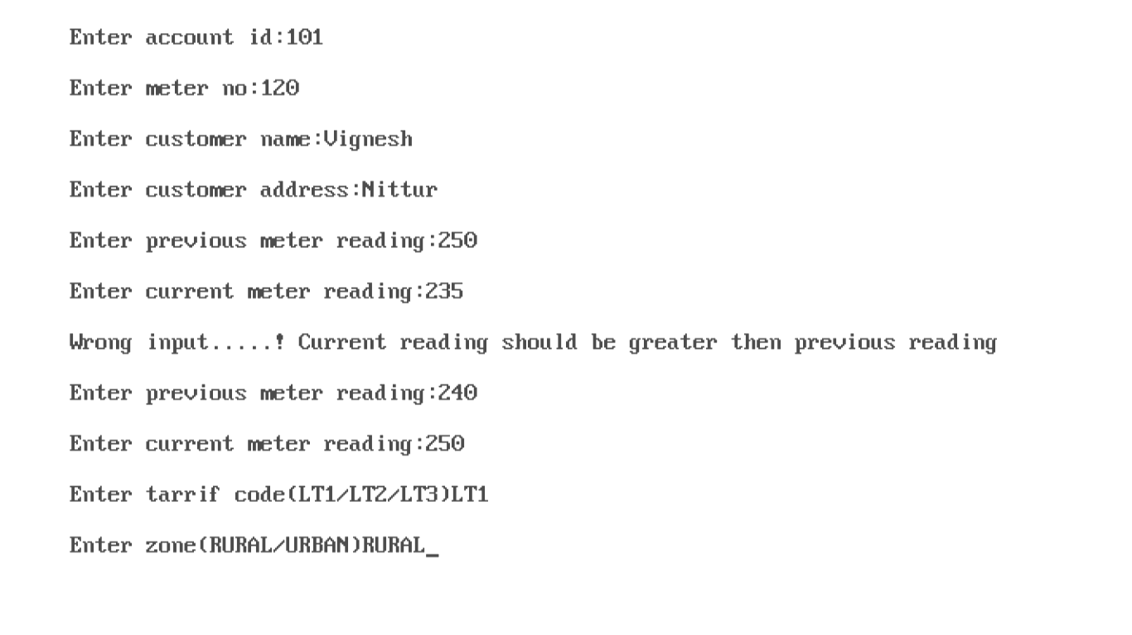

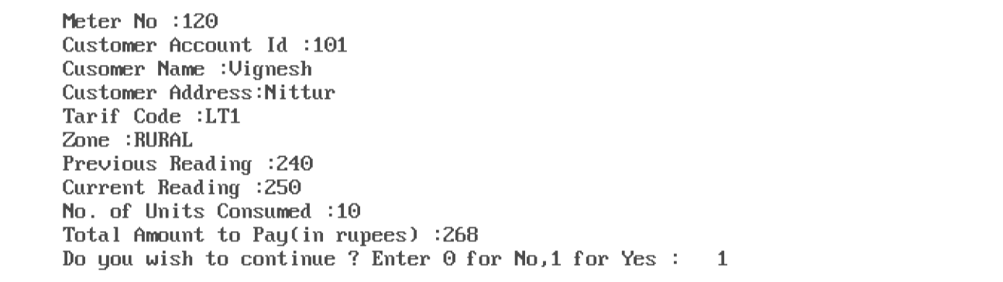

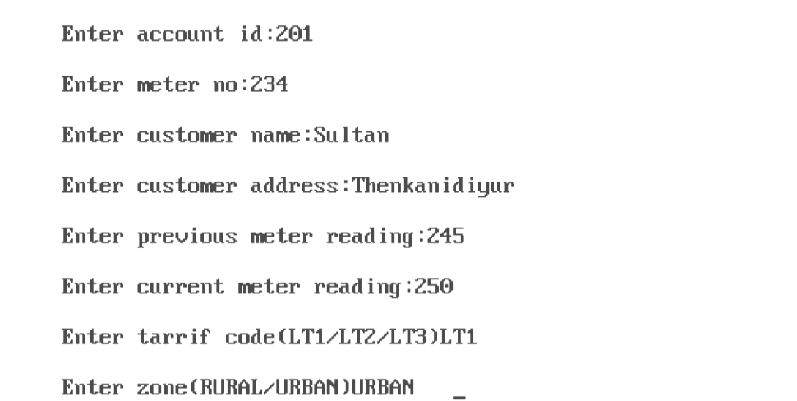

# 

# 

# 

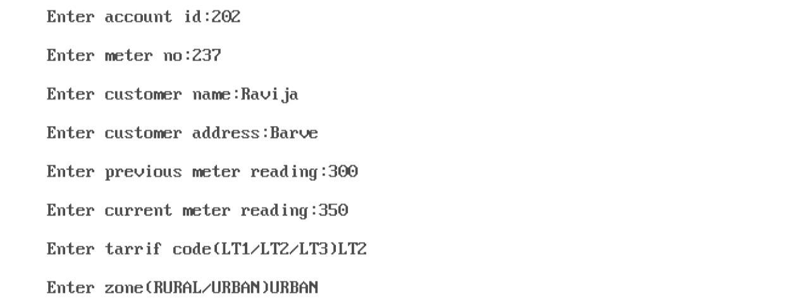

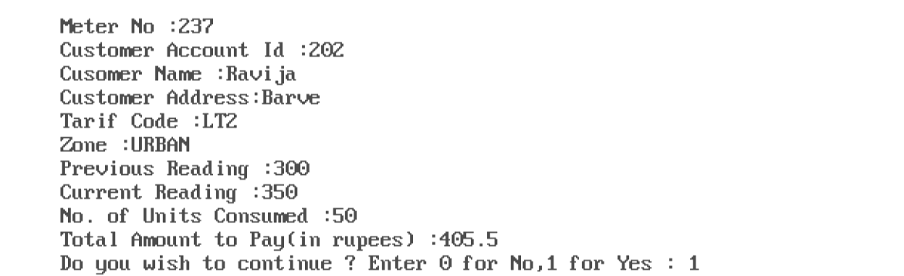

# 

# 

# 

# 

# 2 Using hierarchical inheritance, create a base class ‘ITEM’ with data members item number, title and price. Derive the following items for base class ITEM.

# a) ‘Book’ with author name, publication and pages as the data members.

# b) ‘CD’ with data members - category, time of play and speed.

# Issue desired number of items and print the list of books and CD’s separately. Also print the number of books, CDs and total number of items purchased.

#include<iostream.h>

#include<conio.h>

#include<iomanip.h>

#include<string.h>

#include<stdio.h>

class item

{

protected: int itemno;

float price;

char title[50];

public: void getdata()

{

cout<<"Enter the item no:"<<endl;

cin>>itemno;

cout<<"Enter price:"<<endl;

cin>>price;

cout<<"Enter the title:"<<endl;

cin>>title;

}

void display()

{

cout<<"The item:"<<itemno<<endl;

cout<<"The price:"<<price<<endl;

cout<<"The title:"<<title<<endl;

}

};

class book:public item

{

protected:

char author[50];

char pub[50];

int pages,no;

public:void book_info()

{

cout<<"Enter the name of the author:"<<endl;

cin>>author;

cout<<"Enter the publication:"<<endl;

cin>>pub;

cout<<"Enter the number of pages:"<<endl;

cin>>pages;

cout<<"Enter number of books to be purchased:"<<endl;

cin>>no;

}

int return_book()

{

return(no);

}

void book_dis()

{

cout<<"The Author:"<<author<<endl;

cout<<"The Publication:"<<pub<<endl;

cout<<"The Pages:"<<pages<<endl;

cout<<"The no of books purchased:"<<no<<endl;

}

};

class cd:public item

{

protected: char category[50];

int item,speed,time,num;

public: void cd_info()

{

cout<<"Enter the category:"<<endl;

cin>>category;

cout<<"Enter the speed:"<<endl;

cin>>speed;

cout<<"Enter the time taken:"<<endl;

cin>>time;

cout<<"Enter the number of CD's to be ordered:"<<endl;

cin>>num;

}

int return_cd()

{

return(num);

}

void cd_dis()

{

cout<<"The category:"<<category<<endl;

cout<<"The time:"<<time<<endl;

cout<<"The speed:"<<speed<<endl;

cout<<"Number of CD's purchased:"<<num<<endl;

}

};

void main()

{

clrscr();

book b[20];

cd c[30];

int ch,ci,p,n=0,m=0;

do

{

cout<<"\n Main Menu\n";

cout<<"\n1.Book\n2.CD \n3.Display\n";

cout<<"Enter your choice(1,2,3):"<<endl;

cin>>ch;

switch(ch)

{

case 1:

int bk;

do

{

b[m].getdata();

b[m].book_info();

m++;

cout<<"Do you wish to continue book information ?(1/0)"<<endl;

cin>>bk;

}

while(bk==1);

break;

case 2:

int cs;

do

{

c[n].getdata();

c[n].cd_info();

n++;

cout<<"Do you wish to continue CD information ?(1/0)"<<endl;

cin>>cs;

}

while(cs==1);

break;

case 3:

int total_numbook=0,total_numcd=0;

for(p=0;p<m;p++)

{

cout<<"\n Book Information \n";

b[p].display();

b[p].book_dis();

total_numbook+=b[p].return_book();

}

cout<<"Total number of books ordered:"<<total_numbook<<endl;

for(p=0;p<n;p++)

{

cout<<"\n CD information \n";

c[p].display();

c[p].cd_dis();

total_numcd+=c[p].return_cd();

}

cout<<"Total number of CD's purchased:"<<total_numcd<<endl;

cout<<"\n Total number of items purchased:"<<total_numbook+total_numcd<<endl;

break;

default:

cout<<"Wrong choice !"<<endl;

}

cout<<"Do you wish to continue in the Main Menu ? (1/0)"<<endl;

cin>>ci;

}

while(ci==1);

getch();

}

***Output:***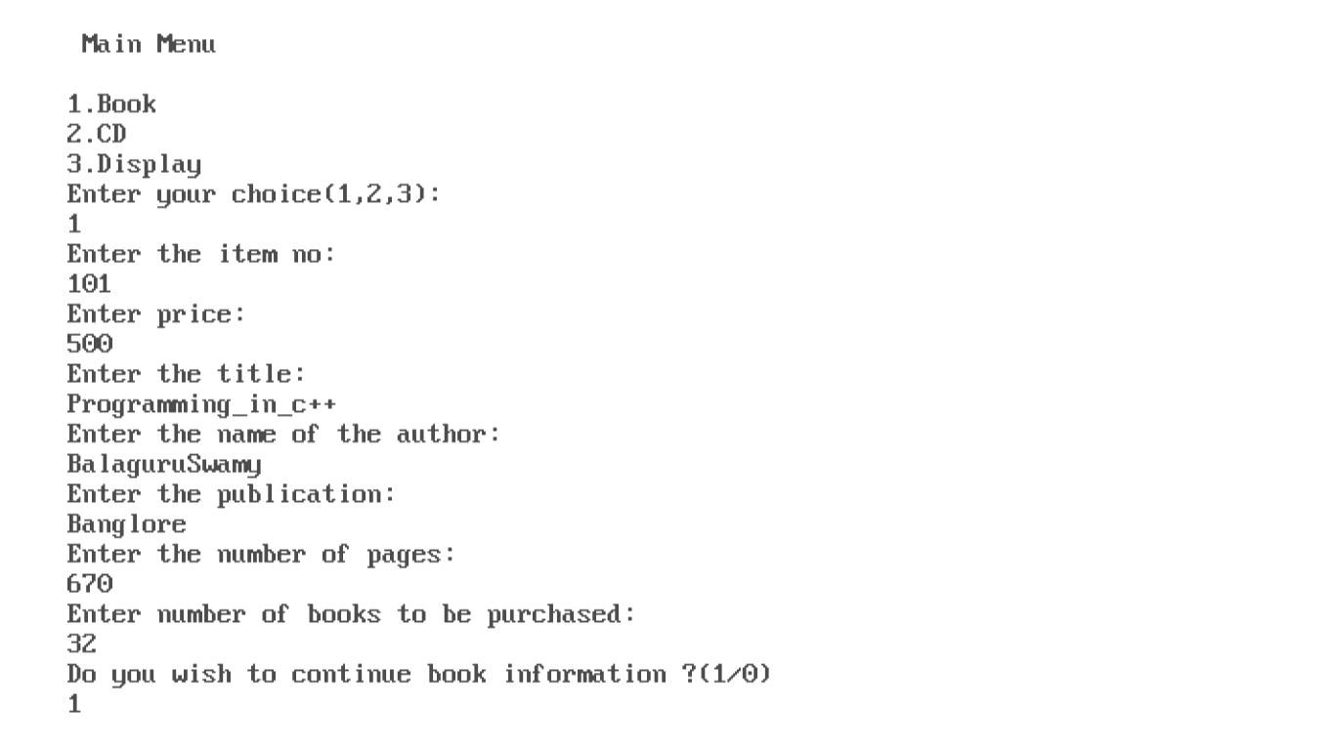

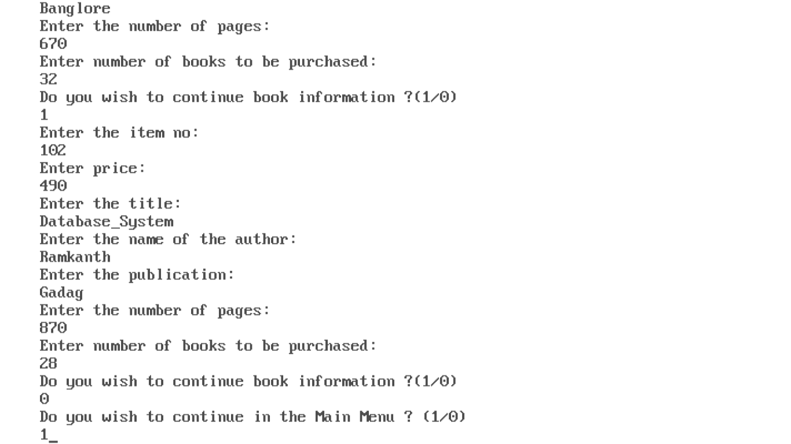

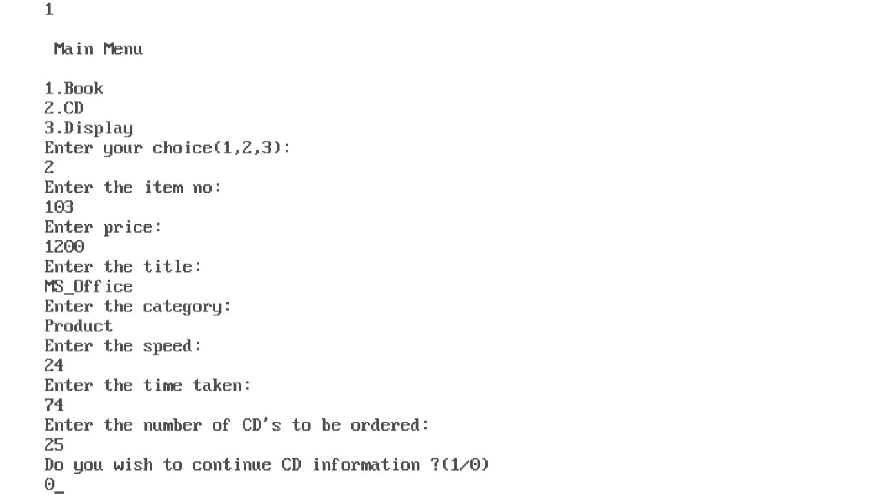

# 

# 

# 3 Using multiple inheritance, write a program to create a class ‘Personnel Information’ which includes name, address and gender as the data members. Another class for ‘Physical Information’ with data members height, weight, blood group. Derive a class called ‘Salary’ which inherits from the above two classes, with employee number, department and salary. Find increment in salary for an employee as follows.

# For Male: In department S or P - 10%

# For Female: In department S or P - 11%.

# (Hint: S for Sales and P for Purchase; for any other department, no increment.)

#include<iostream.h>

#include<iomanip.h>

#include<conio.h>

class personal

{

protected:

char name[50];

char address[50];

char gender;

public:

void getpersonal()

{

cout<<"\nEnter the personal info\n";

cout<<"\nEnter employee name:";

cin>>name;

cout<<"\nEnter the address:";

cin>>address;

cout<<"\nEnter the gender:";

cin>>gender;

}

void putpersonal()

{

cout<<setw(10)<<endl<<"Name: "<<name<<endl;

cout<<setw(10)<<endl<<"Address: "<<address<<endl;

cout<<setw(10)<<endl<<"Gender: "<<gender<<endl;

}

};

class physical

{

protected:

float height,weight;

char bg[5];

public:

void getphysical()

{

cout<<"\nEnter the personal info\n";

cout<<"\nEnter the height:";

cin>>height;

cout<<"\nEnter the weight:";

cin>>weight;

cout<<"\nEnter the blood group:";

cin>>bg;

}

void putphysical()

{

cout<<setw(10)<<endl<<"Height: "<<height<<endl;

cout<<setw(10)<<endl<<"Weight: "<<weight<<endl;

cout<<setw(10)<<endl<<"B-Group: "<<bg<<endl;

}

};

class salary:public personal,public physical

{

private:

int eno;

char dept;

float inc,salary;

public:

void getsalary()

{

personal::getpersonal();

physical::getphysical();

cout<<endl<<"\nEnter the salary info:";

cout<<"\nEnter employee number:";

cin>>eno;

cout<<"Enter the salary:";

cin>>salary;

cout<<"Enter the department:";

cin>>dept;

}

void putsalary()

{

personal::putpersonal();

physical::putphysical();

cout<<setw(10)<<endl<<"Emp No: "<<eno<<endl;

cout<<setw(10)<<endl<<"Department: "<<dept<<endl;

cout<<setw(10)<<endl<<"Salary: "<<salary<<endl;

}

void inc_sal()

{

if(dept=='p'||dept=='s'||dept=='P'||dept=='s')

{

if(gender=='m'||gender=='M')

salary+=salary*0.1;

else

salary+=salary*0.11;

}

}

};

void main()

{

salary s;

clrscr();

s.getsalary();

s.inc_sal();

s.putsalary();

getch();

}

***Output:***

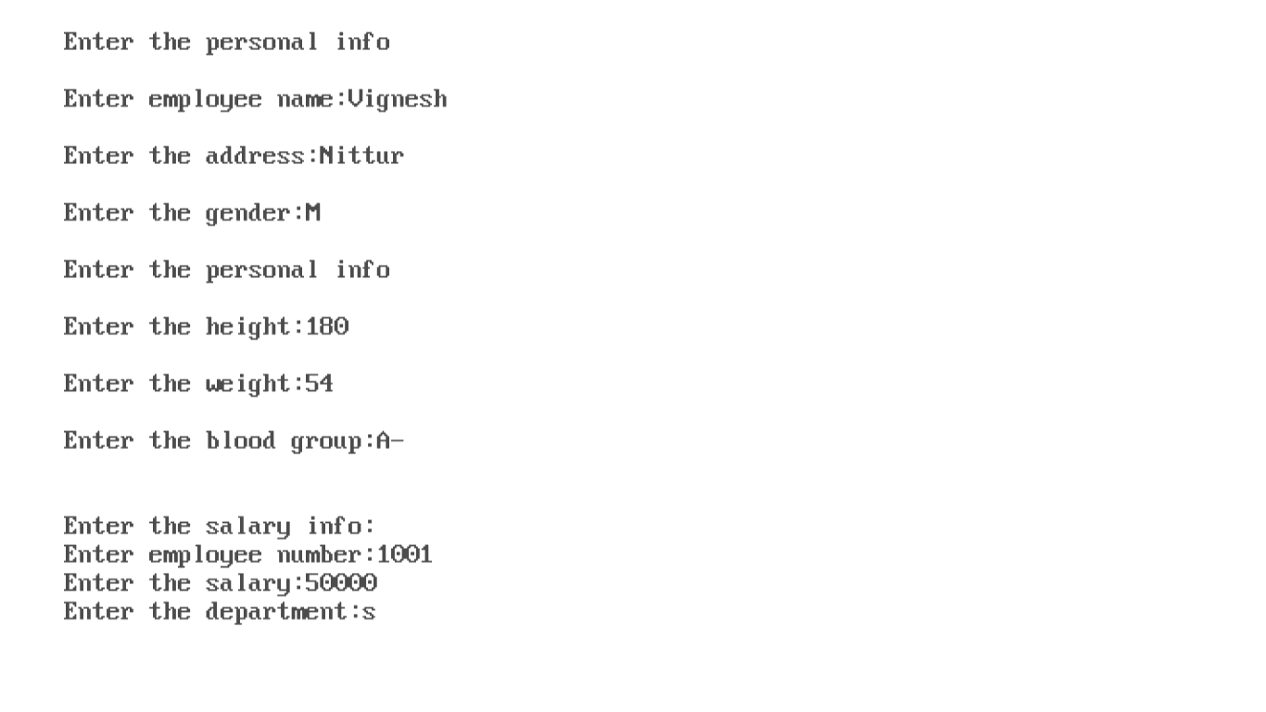



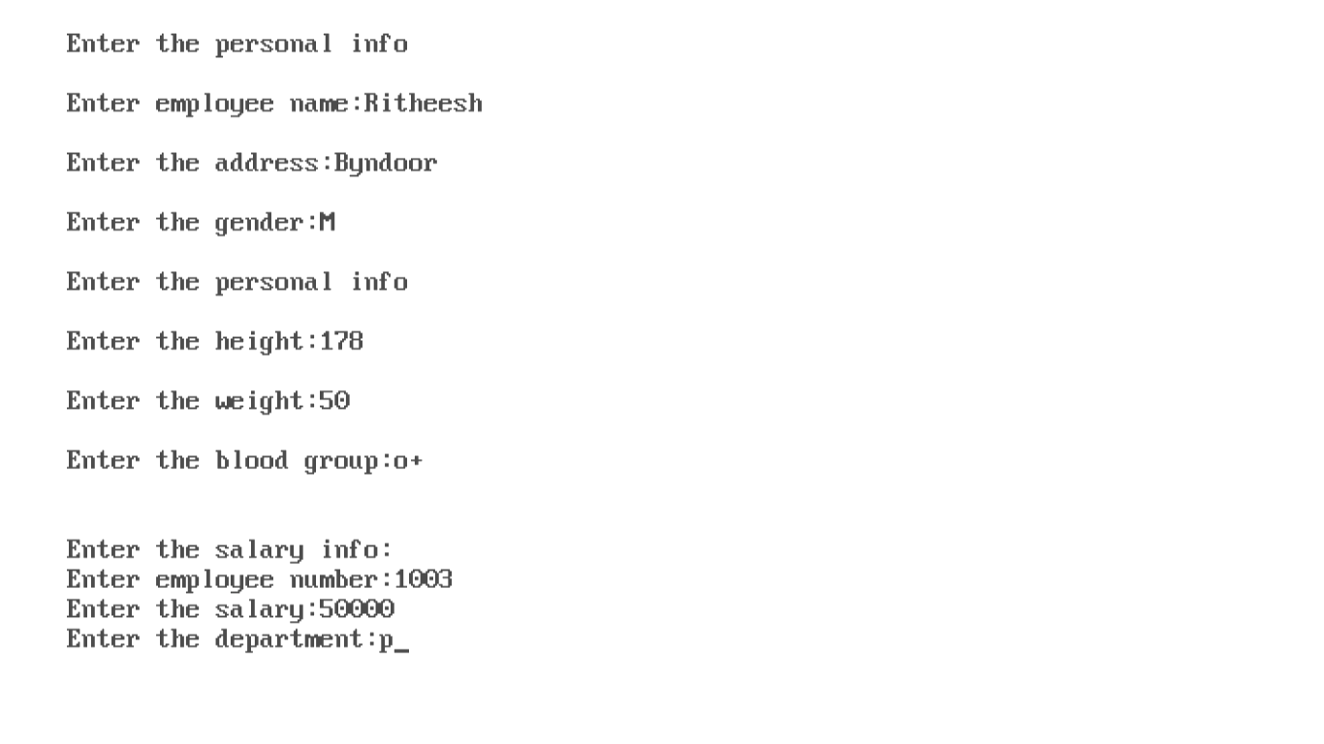

# 

# 

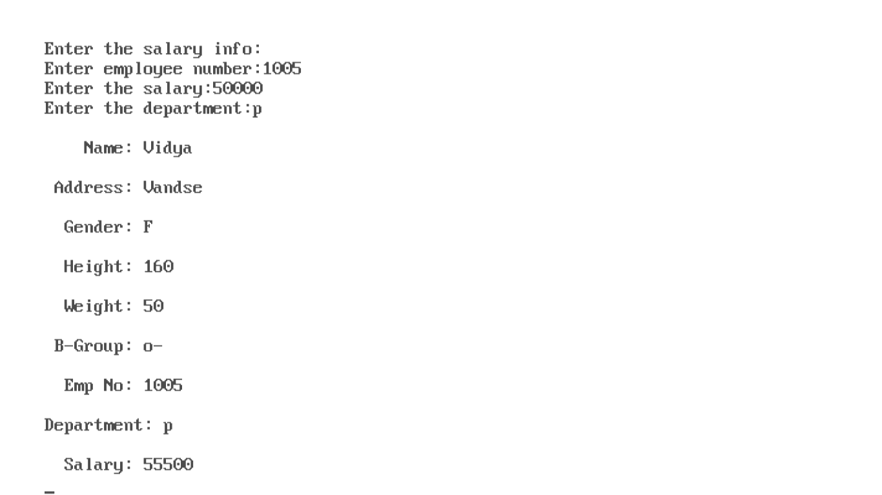

# 

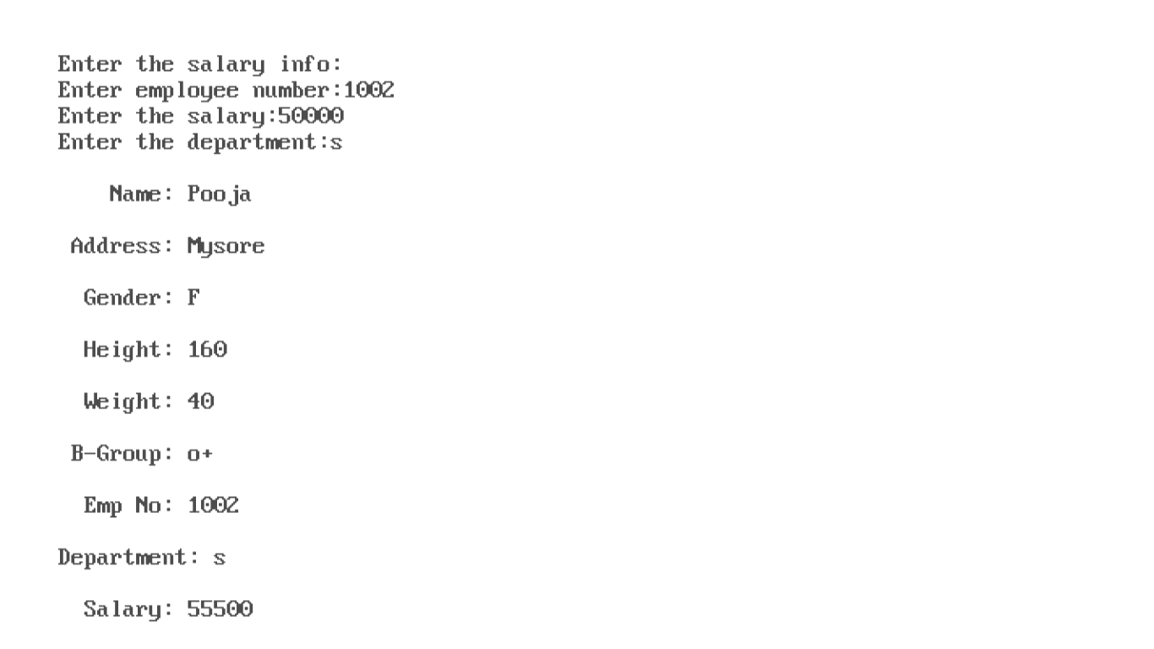

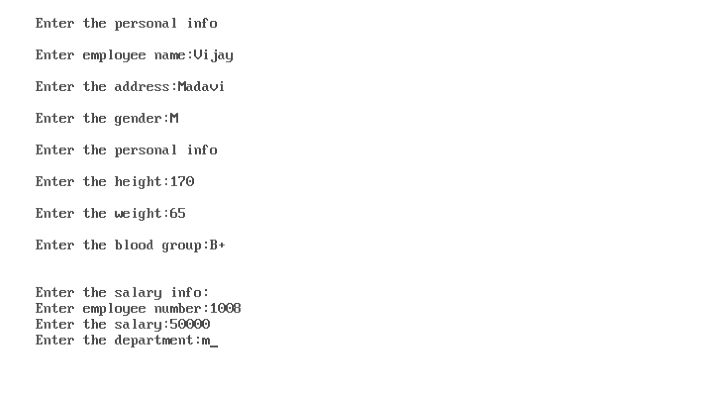

# 

# 4 Create a class Employee containing name and EmpNo. Create two more classes Manager with data members department name and number of employees under that department, and Scientist with data members year and number of publications. Using the concept of containership, read all the information of a Scientist and Manager and display the information in a neat format.

#include<iostream.h>

#include<conio.h>

#include<iomanip.h>

class employee

{

private:

char name[20];

int emp_no;

public:

void getdata()

{

cout<<"Enter the Employee name and Employee number:"<<endl;

cin>>name>>emp_no;

}

void putdata()

{

cout<<"\nEmployee name: "<<name<<endl;

cout<<"Employee number: "<<emp_no<<endl;

}

};

class manager

{

char dept_name[20];

int no_emp;

employee emp;

public:

void getdata()

{

emp.getdata();

cout<<"Enter the Department name and number employees in department:"<<endl;

cin>>dept_name>>no_emp;

}

void putdata()

{

emp.putdata();

cout<<"Department name: "<<dept_name<<endl;

cout<<"Number of employees: "<<no_emp<<endl;

}

};

class scientist

{

private:

char name[20];

int year,number,no_pub;

employee emp;

public:

void getdata()

{

emp.getdata();

cout<<"Enter the year and no of publications:"<<endl;

cin>>year>>no_pub;

}

void putdata()

{

emp.putdata();

cout<<"This year is : "<<year<<endl;

cout<<"The number of publications: "<<no_pub<<endl;

}

};

void main()

{

int i,n,j=0,k=0;

char ch;

manager mng[100];

scientist sci[100];

clrscr();

cout<<"Enter the total no of employees : ";

cin>>n;

for(i=0;i<n;i++)

{

cout<<"Manager or scientist (m/s) : "<<endl;

cin>>ch;

if(ch=='m')

mng[j++].getdata();

else

sci[k++].getdata();

}

cout<<"\nInformation about Manager: "<<endl;

for(i=0;i<j;i++)

mng[i].putdata();

cout<<"\nInformation about Scientist: "<<endl;

for(i=0;i<k;i++)

sci[i].putdata();

getch();

}

***Output:***

